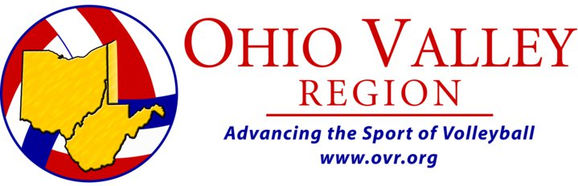

Candidate Profile for Board of Directors, Ohio Valley Region, Inc. /USAV

Signature ________________________________________________________________________Date____________________

Address _________________________________________________________________________________________________

Phone-Home_______________________________Work ____________________________Fax __________________________

E-mail Address ____________________________________________________________________________________________

For how many years have you been involved in volleyball?________________________________________________________

OVR/USAV Club Affiliation _________________________________________________Level ____________________________

Experience playing volleyball
________________________________________________________________________________

Experience in administering volleyball as a club director, coach, league director, tournament director or official
___________________________________________________________________________________________________________

Why would you like to be on the Board of Directors for the Ohio Valley Region, Inc. /USAV?

