How Parents can communicate with the Team vis SportsEngine:
Step 1: Login to your SportsEngine
Step 2: Click on to “My Account”, Click “Continue”
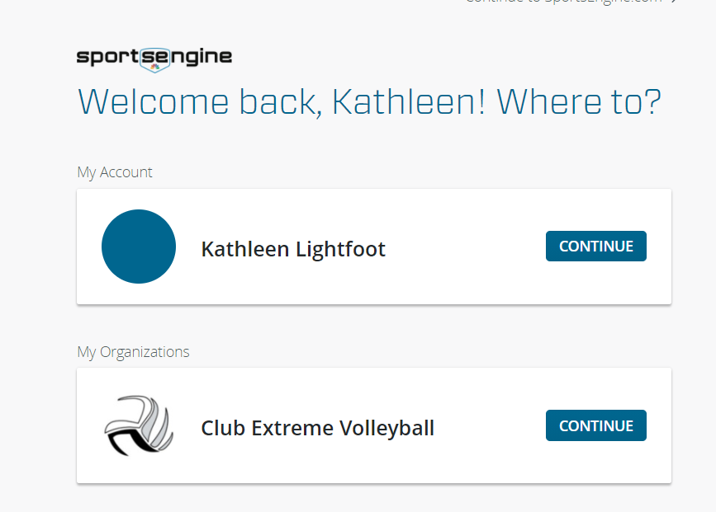
Step 3: On the left margin menu, CLICK on “Groups” This opens the “Groups” Page
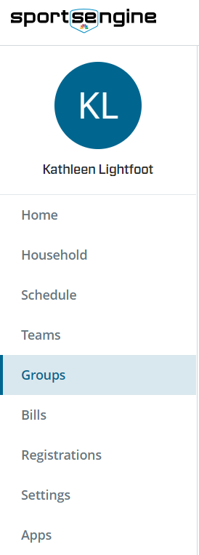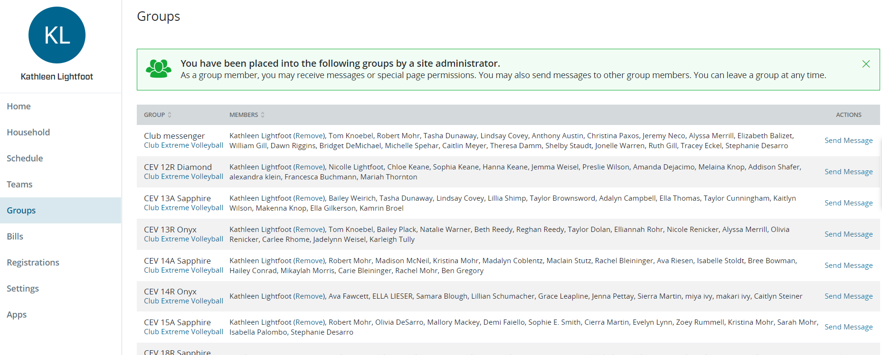
Step 4: On the right side of page, CLICK “Send Message” to the team you would like to communicate, then it opens the dialog box to email. CLICK on “All” or “Selected”. “All” mean everyone within group and “Selected” , you can choose who you would like to communicate.
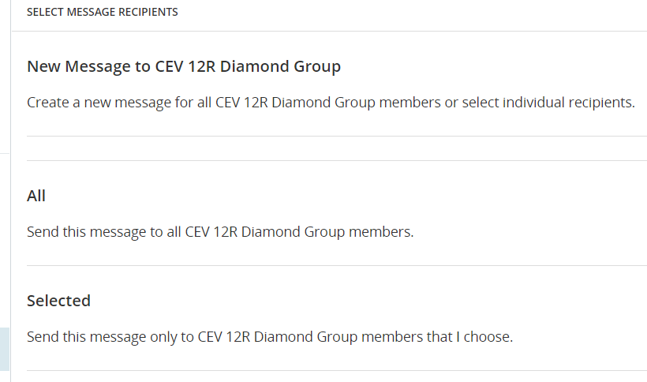
Choose either ‘All’ or ‘Selected’
Step 5: Example is for “Selected” – You may search via search window or use slide bar in the profile window.
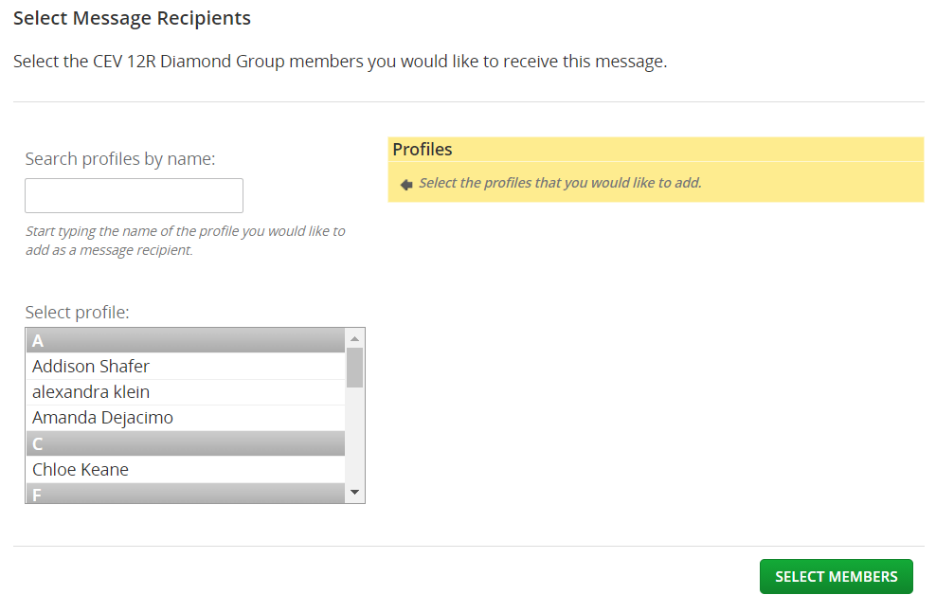
Step 6: When you select the profiles you would like, they will appear in the beige box to the right of the Profile search window. When you are done selecting the players profiles, CLICK the Green “Select Members” Button
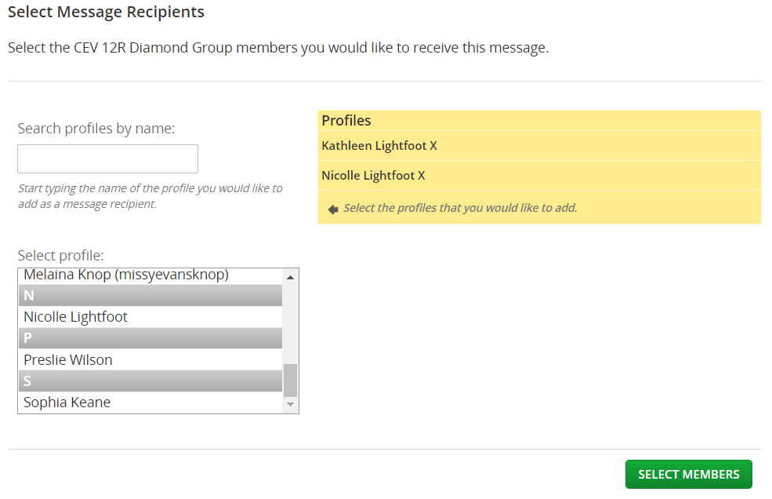
Step 7: After clicking the ‘Select Members’ button, the email dialog window appears
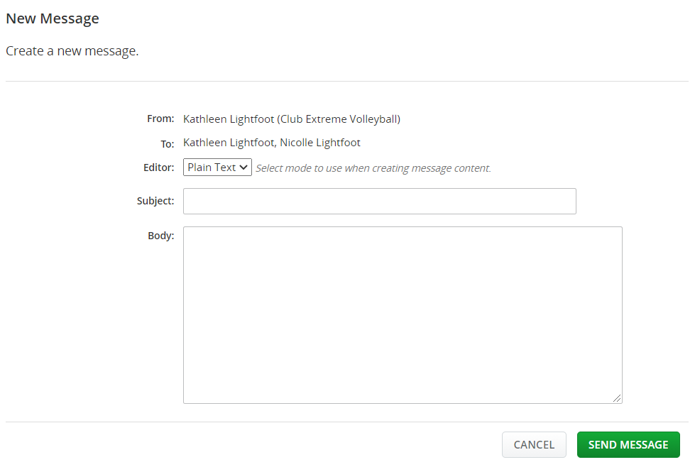
Step 8: Enter you message in the dialog email box and “CLICK” the “Send Message” Button to send

