How Club creates a Groups within SportsEngine
Group or Smart Group: You can manually add people to a group anytime. You can also use the filters to create Smart Groups, which automatically add people that fit the criteria you choose.
Step 1: Login to SportsEngine
Step 2: Select ‘Continue’ in ‘My Organization’
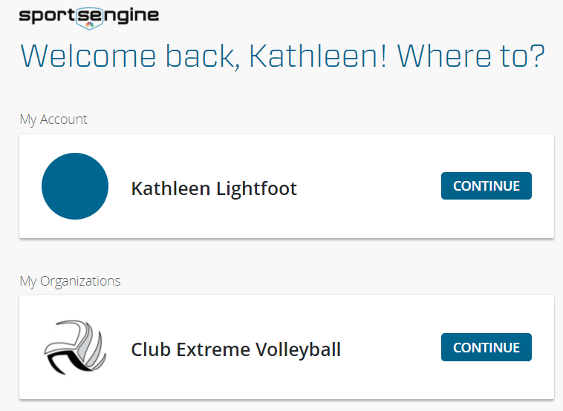
Step 3: In the Left-hand margin, CLICK and open the drop-down to find the ‘Directory’
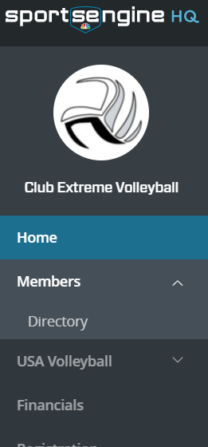
Step 4: CLICK on the “ADD GROUP” button. This is located on the right side of the page and opens the dialog box for naming the group and privacy settings
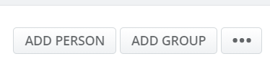
Step 5: Enter the Group’s name and choose the privacy setting then CLICK ‘ADD’ button

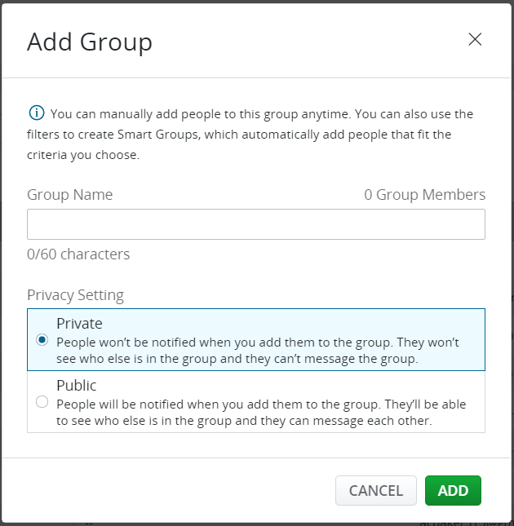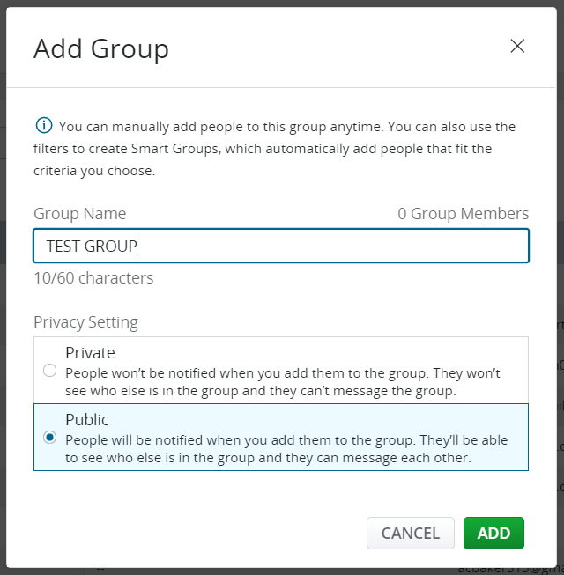

Step 6: Your group is now created, time to add your group members

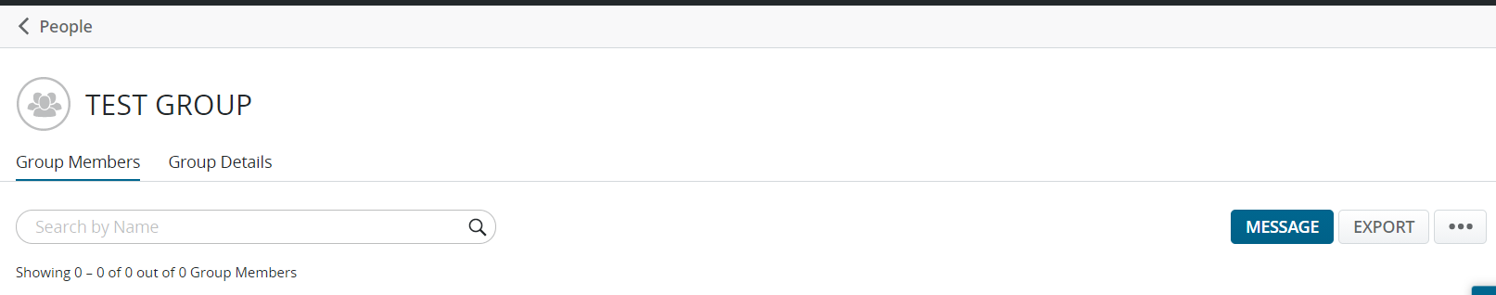

Step 7: CLICK on the 3-Dots, a window opens then CLICK ‘Add Group Members’, the next window opens

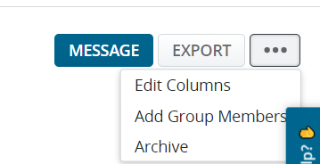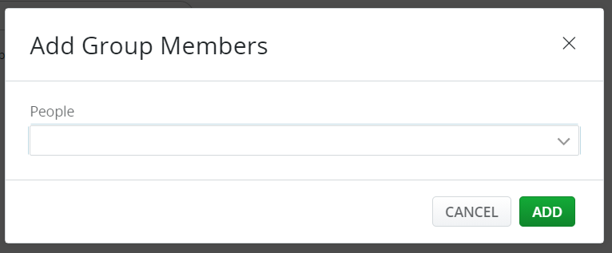

Step 8: Begin typing in the 1st characters of the member you want in the group and names begin to appear – select the member you want in the group and press ‘enter’, this will add the member to the people search bar. Start typing the next member and locate then select and so on till everyone is added to the group
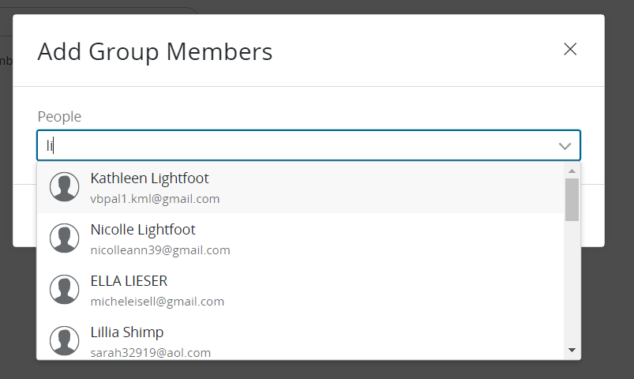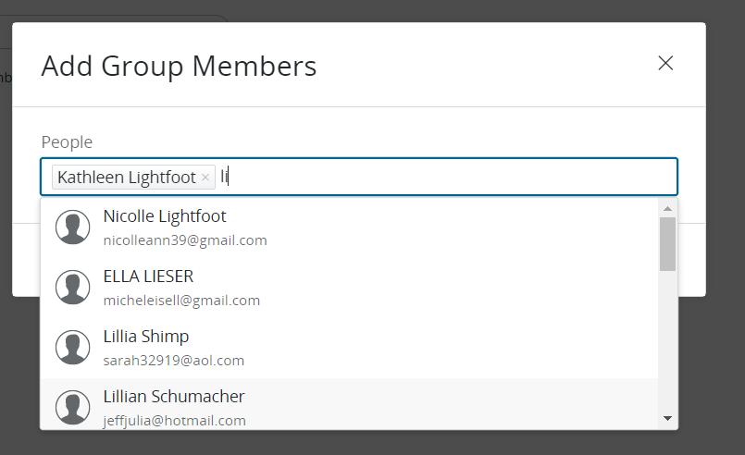
Step 9: CLICK ‘Add’ and your Group is created
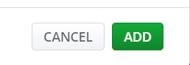
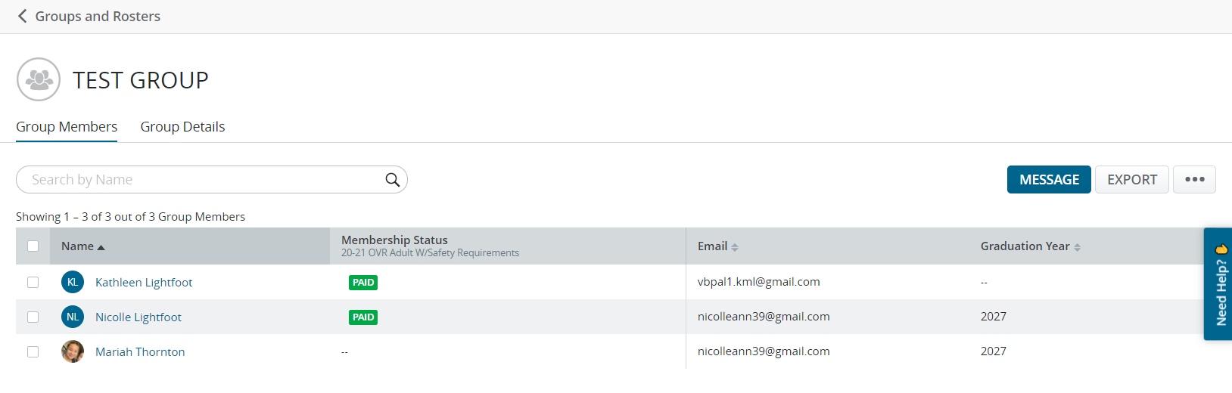
Step 10: Adding additional members just by clicking on the 3-Dots and then click on ‘Add Group Members’
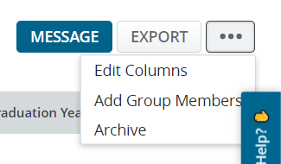
Step 11: To remove members, Click on Box in front of members name you want to remove
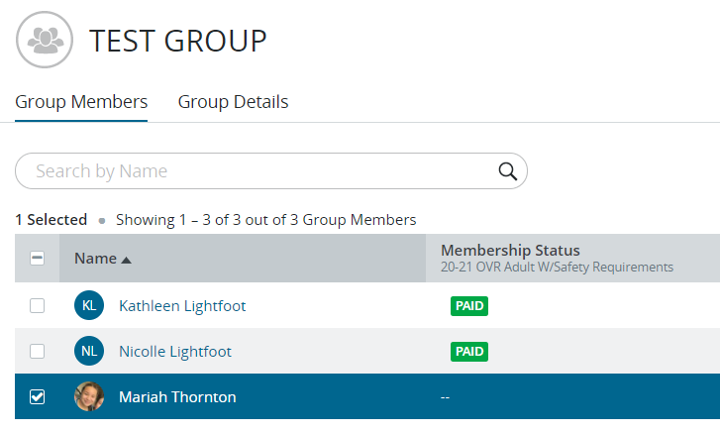
Step 12: Locate the 3-Dots in the right corner and click on them. The drop-down window gives youe three choices, choose ‘Remove People’
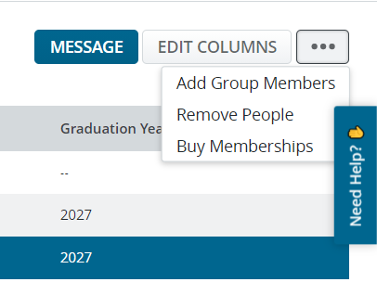
Step 13: This window appears, verify the removal and click YES
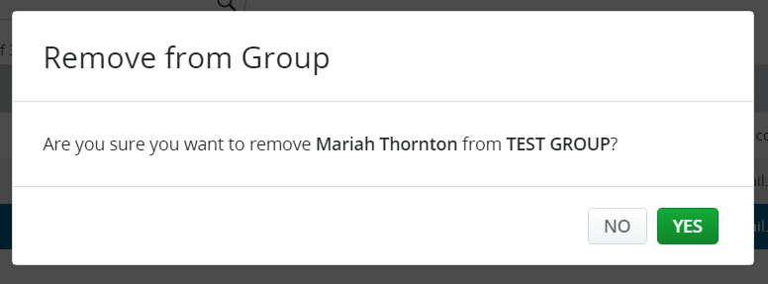
And the member has been removed
